

Year 10 Science
Earth & Space 1 Test: Global Systems

SECTION 1: MULTIPLE CHOICE (1 mark each)
Circle your answer on the multiple choice answer sheet.

- The layer of the Earth in which living things are found is called the
  - atmosphere
  - biosphere
  - lithosphere
  - hydrosphere

- The asthenosphere is also known as
  - crust
  - mantle
  - air
  - ocean

- The most abundant compound in air is
  - nitrogen
  - oxygen
  - carbon dioxide
  - water

- Which of the following statements is correct?
  - As air rises it cools by about 1ºC for every 100 m it rises.
  - Air pressure is the percentage of water vapour needed to form dew.
  - Winter is colder than summer because the Earth’s orbit is further from the sun in winter.
  - The line where warm air meets cold air is called a cyclone.

- In the carbon cycle, inorganic carbon dioxide is converted to organic carbon compounds by
  - respiration.
  - decomposition.
  - fossilisation.
  - photosynthesis.

- In the water cycle, the majority of the water exists as
  - sea water.
  - water vapour in air.
  - clouds.
  - part of living things.

- Nitrogen is found in living tissues as part of compounds called
  - carbohydrates.
  - fats.
  - proteins.
  - water.

- Which of these is not an example of a fossil fuel?
- Oil
- Coal
- Gas
- Water

- Which of these is a natural source of carbon emissions?
  - burning fossil fuels
  - volcanoes
  - animals such a cows expelling methane
  - photosynthesis

- Climate change is not caused by
  - greenhouse gas emissions from energy production.
  - tree clearing.
  - gas emissions from farm animals.
  - using too much water.

- The main gases that are responsible for global warming are
  - oxygen and hydrogen.
  - chlorofluorocarbons (CFCs).
  - carbon dioxide and methane.
  - sulfur dioxide and nitrogen dioxide.

- Which of these is not a type of precipitation?
  - rain
  - hail
  - snow
  - wind

- Cyclones form in
  - very low pressure systems over land
  - very high pressure systems over cool oceans
  - very low pressure systems over tropical oceans
  - very high pressure systems over deserts

The next two questions refer to the following diagram, which shows global patterns of air movement.
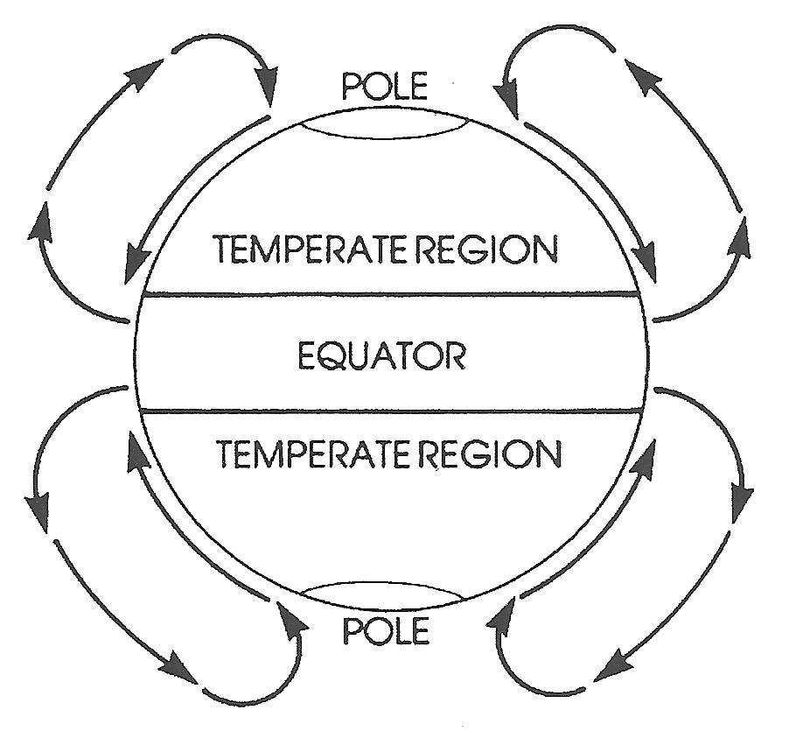

- Which of the following statements is true?
- In the Equatorial region, hot air rises.
- Warm Polar air moves towards the equator.
- As it moves towards the equator, hot air cools and sinks.
- Air moves from one pole to another.

- Fronts occur when warm air masses meet cool air masses. These are most likely to be found
  - near the equator
  - in the tropics
  - in the temperate regions
  - near the poles

SECTION 2: WRITTEN
Write your answers on the answer sheet provided.

1. The diagram below shows how water may move in an ecosystem
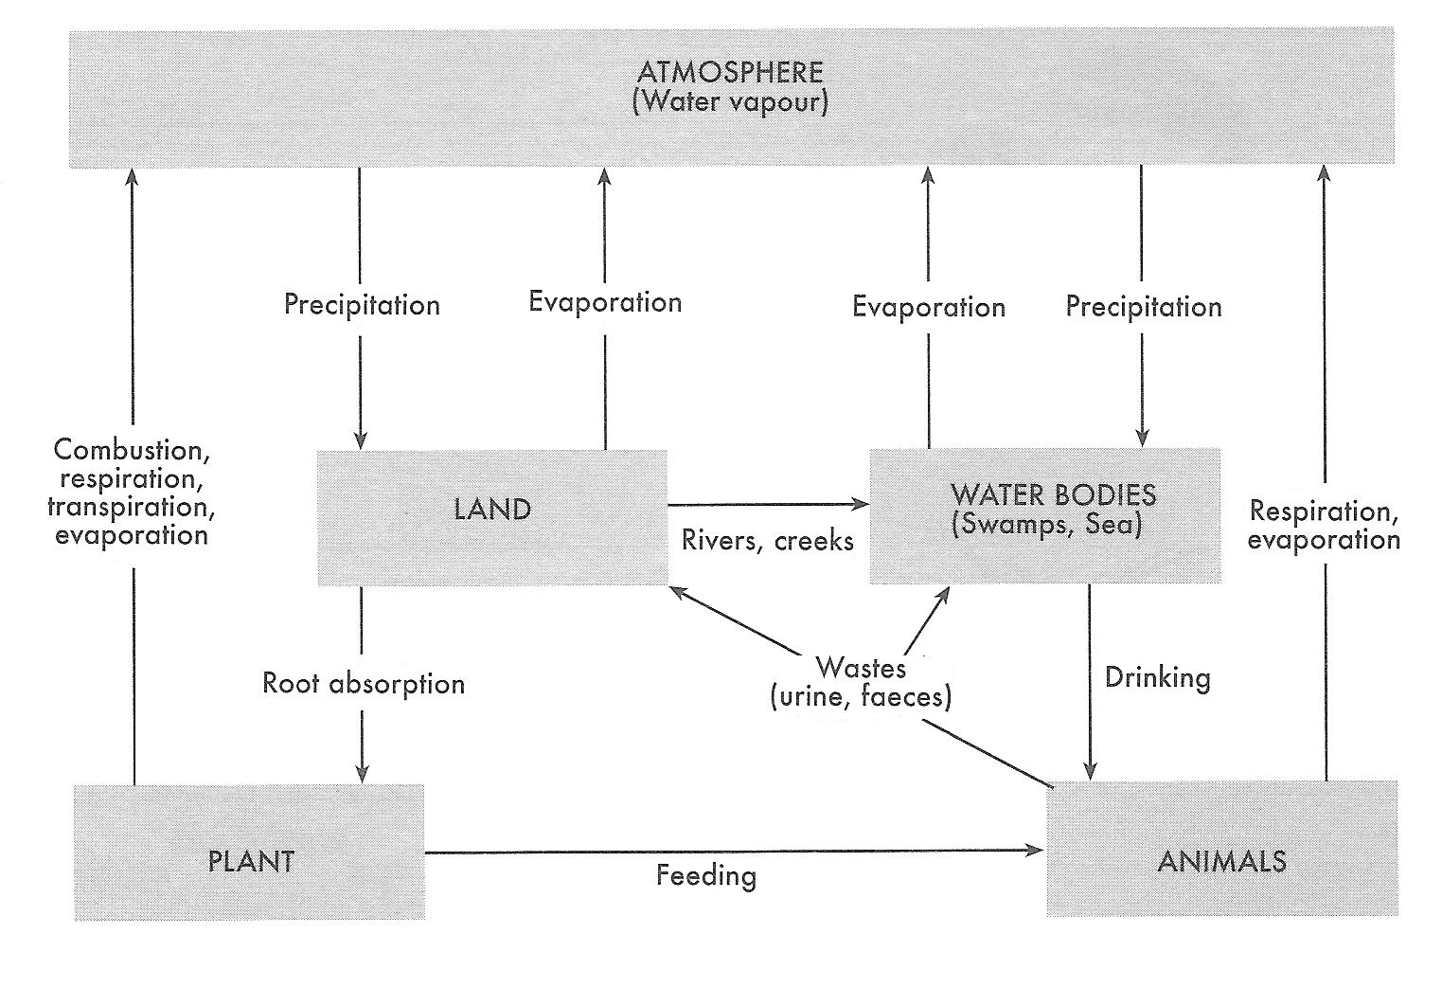

- Define transpiration.
- How do plants obtain water?
- Name four ways that water can enter the atmosphere. (6)

- The diagram below is a summary of the nitrogen cycle
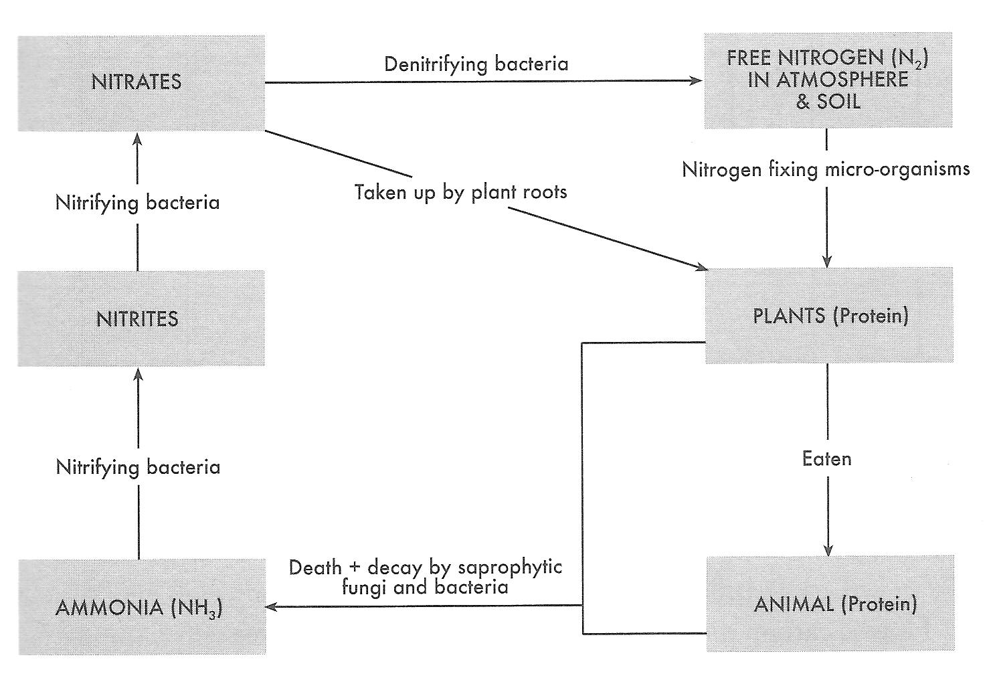

a) How do animals obtain their nitrogen?
b) What do plants and animals use nitrogen for?
c) When plants and animals die, what happens to the nitrogen in their bodies?
d) In what form do denitrifying bacteria release nitrogen? (4)

3. The diagram below shows the movement of carbon through an ecosystem
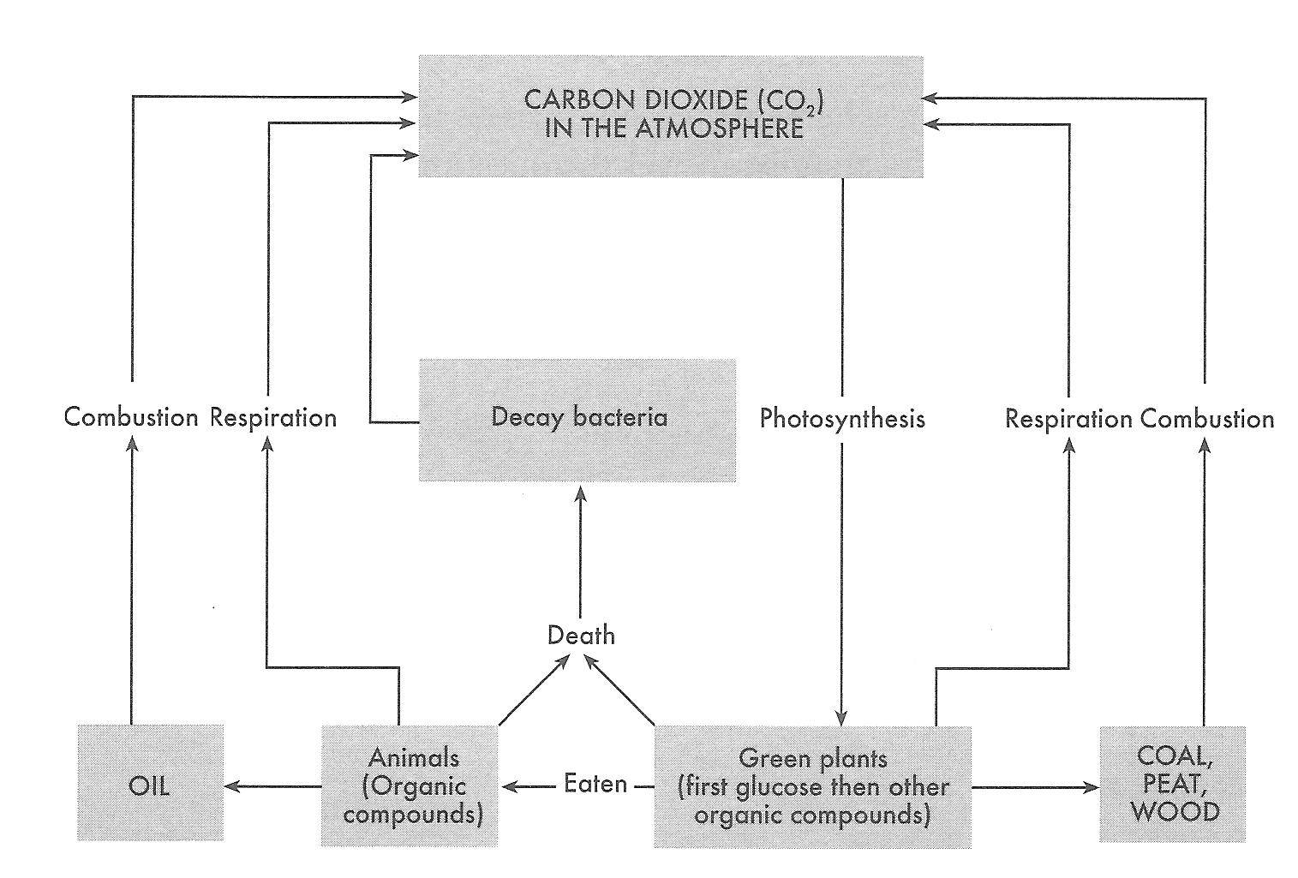

- How is carbon dioxide removed from the atmosphere?
- Name two processes that release carbon dioxide into the atmosphere.
- Which compound shown in the diagram is an example of a fossil fuel?
- Name one organic molecule which contains carbon. (5)

END OF TEST (OUT OF 30 MARKS)

